**LAB # 4**

**Start, Sleep and Stop methods of multithreading**

**OBJECTIVE:**

Understanding concurrency by start, sleep and stop thread functions.

**Lab Task:**

By using start, stop and sleep methods of threading, print alphabets of English from A-Z. (Hint: use math.random method for getting random numbers and then convert them into characters, print 26 characters under rum method loop with fluctuating visualization through sleep method).

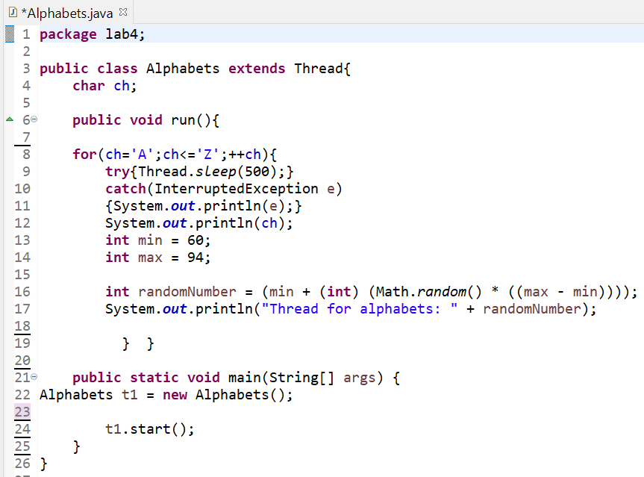

**OUTPUT:**

